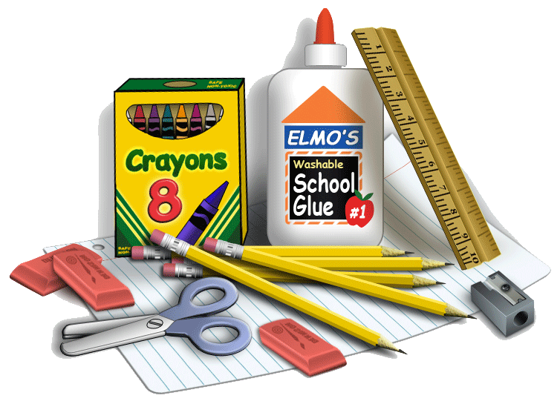

Dear Parent(s),
The following supplies are needed to get your student ready for the school year. If you are able to donate any one or more of the items below in our wish list, it would be greatly appreciated! Please let me know if you have any concerns about the supply list:
- Pencils
- Cap Erasers
- Markers
- Crayons
- Colored Pencils
- Pencil Box
- Old sock or eraser
- Homework folder
- Two plain colored folders (Blue and Yellow)
- One writing notebook
- Glue stick
OUR CLASSROOM WISH LIST:

- Clorox Wipes
- Tissues
- Hand Sanitizer
- Paper Towels
- Expo Markers

Thank you,
Ms. Griffin

